# **Invite (Single and Bulk) and Registration Process steps:**

**Invite Process initiated by VSA/Sponsor through UI:**

1. Clicks on the invite User or VSA quick link. employee “type” {VSA or User}
2. Selects the "Organization Name"
3. Based on the selected Organization, GLNS are displayed
4. Enter User's email ID.
5. Clicks submit.
6. Upon submission, end user's identity cube will be created and provisioned with PING ID.
7. End user will receive an email with registration link. When user clicks on the link ,an OTP will be sent out to the user . Upon entering the OTP , user will be redirected to enter basic profile information and set the password.
8. After the registration has been completed by the end user, SailPoint will provision user to PING Directory(ou=people & ou=persona) and provision user to a group based on the function selection during the invite process.
9. End User will receive an email confirmation containing VID and login page URL and instructions with further actions.
10. The user will be able to login to applications using the VID/email ID and password set during the registration process.

**Bulk Invite Process:**

1. VSA/ Sponsor clicks on the Bulk Invite Vendor Users quick link.
2. Selects the organization.
3. Downloads the sample input file. File contains following fields : Email
4. Clicks on Browse file to upload the csv file with data from computer to SailPoint Vendor Identity Portal.
5. Clicks submit.
6. Upon submission ,SP validates if user's email id is valid
7. Post validation SailPoint sends an email to the requestor with summary. No. of records processed, unprocessed etc.
8. End user's identity cube will be created and provisioned with PING ID.
9. End user will receive an email with registration link. When user clicks on the link ,an OTP will be sent out to the user . Upon entering the OTP , user will be redirected to enter basic profile information and set the password.
10. After the registration has been completed by the end user, SailPoint will provision user to PING Directory(ou=people & ou=persona) and provision user to a group based on the function selection during the invite process.
11. End User will receive an email confirmation containing VID and login page URL and instructions with further actions.
12. The user will be able to login to applications using the VID/email ID and password set during the registration process.
13. SailPoint Login Page:

URL - <https://vendoridentity.stage.bestbuy.com/identityiq>

Credentials – VID\Password or NAQAAID\Password

1. SailPoint Home page

1. Can choose the option as needed to invite new users

1. Click on Invite Vendor User(S) link and submit the invite form.

*[For Testing, please create ID’s with prefix “partnersupport” in their email address so that we can route the emails to your best buy account]*

1. Invite sent successfully.

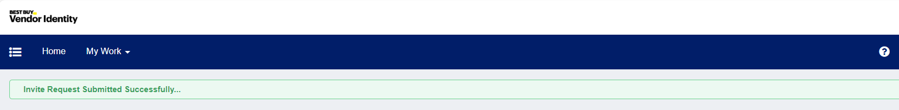

1. Invite would be sent to user.

1. Click on the Get Started link to initiate Registration.

1. Click on Send Code to get an OTP.

*[As we cannot access OTP’s from non-existent recipient address, all the OTP’s are defaulted to our test mailbox, these notifications would be redirected to business/app team from IAM team]*

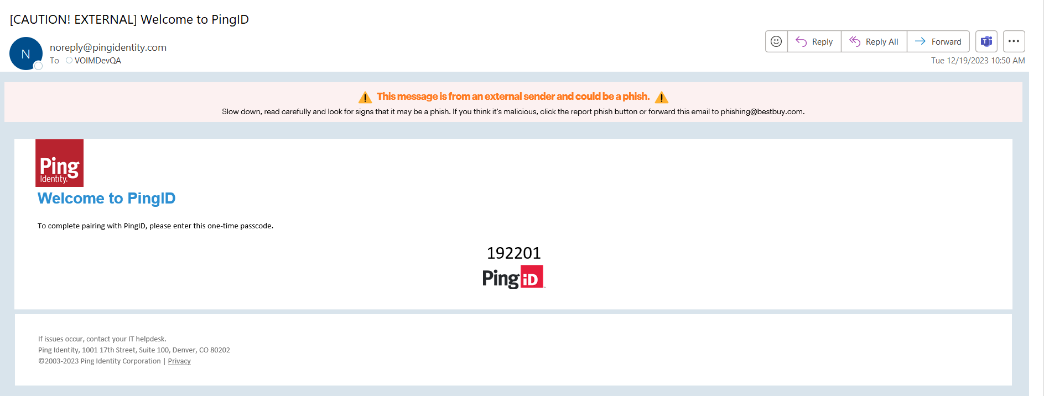

1. Enter the OTP from email and click on Submit.

1. Registration form is loaded, enter all the required attributes and click on Next

1. Enter the password, should meet password policy. Click on Next

1. Confirmation page is displayed with entered values. Click on Submit Request

1. Confirmation message is displayed.

1. End user will receive a Welcome email with the VID details.

1. User can login to SailPoint using the URL.

<https://vendoridentity.stage.bestbuy.com/identityiq>

**[VID and password set during registration]**

# **ICM Application Request Submission**

**Approval Workflow:**

|  |  |  |
| --- | --- | --- |
| **SL No** | **Description** | **Approval Status** |
| 1 | End User submits request | VSA should approve, after approval ICM account is provisioned |
| 2 | VSA submits the request | Auto Approved, ICM account is provisioned |
| 3 | Sponsor submits the request | Auto Approved, ICM account is provisioned |
| 4 | Escalation to Sponsor | If end user submits the request and VSA is not approved for 7 days, then escalated to sponsor |

## Steps to submit the request:

1. Login to SailPoint application using URL : <https://vendoridentity.stage.bestbuy.com/identityiq>
2. Home page is loaded.

1. Click on menu 🡪 Manage User Access

1. Search for the user to request the access and select, then click next button or step 2 Manager Access

1. Click on the Search icon to load the roles to add/remove.

1. Select **Icertis Contract Management role and click next.**

1. Review and submit the request

1. Request is submitted.

## Steps to Approve the requests:

1. Login as VSA/Sponsor to SailPoint
2. Home page is loaded, approval page can be loaded by clicking on highlighted options below

1. Approval page is loaded, approver can either Approve or Deny request

